TITLE OF THE PAPER
Kim López-Güell, Albert Prats-Uribe, Jotun Hein, Daniel Prieto-Alhambra

SUMMARY

Background
Mandatory COVID-19 certification (Covid Passport) was introduced at different times in the four countries of the UK. We aimed to study the effect of this intervention on the incidence of cases and hospital admissions.

Methods
The main outcome was the weekly averaged incidence of COVID-19 cases and hospital admissions. We performed Negative Binomial Segmented Regression (NBSR) and Autoregressive Integrated Moving Average (ARIMA) analyses for the four countries (England, Northern Ireland, Scotland and Wales), and fitted Difference-in-Differences models to compare the latter three to England, as a negative control group.

Findings
Covid Passports led to a decrease in the incidence of cases and hospital admissions in Northern Ireland, as well as in Wales during the second half of November. The same was seen for hospital admissions in Wales and Scotland during October. In Wales the incidence rate of cases in October already had a decreasing tendency, as well as in England, hence a particular impact of Covid Passport was less obvious. Method assumptions for the Difference-in-Differences analysis did not hold for Scotland. Additional NBSR and ARIMA models suggest similar results, while also accounting for correlation in the latter. The assessment of the effect in England itself leads to believe that this intervention might not be strong enough for the Omicron variant, which was the prevalent one at the time of introduction of Covid Passport in the country.

Interpretation
Mandatory Covid Passports reduced COVID-19 transmission and hospitalisations when Delta predominated in the UK, but lost efficacy when Omicron became the most common variant.

Funding
tbc

INTRODUCTION

More than a year after the emergence of SARS-CoV-2, widespread transmission continues. To date, the virus has caused more than 1640000 cases, 176000 deaths and 690000 hospital admissions in the UK. All around western countries there has been a need to balance restrictions to fight the pandemic while controlling their impact on society.

Soon after the introduction of the Delta variant of the virus to the UK over the summer, it became the dominant one. Recently, the newly discovered Omicron variant entered the UK, its first case being reported in late November . The UK Health Security Agency estimates the current prevalence of Omicron to be higher than 90%, having quickly overcome Delta as the most common variant (1).

Since its emergence, various non-pharmaceutical interventions were introduced by several countries in Europe to fight against the COVID-19 pandemic, with adverse socio-economic side effects. Their aim was to slow down the pandemic by restricting mobility. Several papers suggest some of them had an effect in reducing COVID-19 transmission (2), (3), (4). Recently, mandatory COVID-19 certification regulating access to public venues, nightclubs or cultural events was implemented in some countries, using proof of at least two doses of an approved vaccine, negative test (usually within the last 2 days) or a recovery certificate of a recent infection (usually within the last 6 months) (5). Many voices have arisen expressing concern over its effectiveness. Some studies report increase vaccine uptake after its implementation (6), (7), but there is a lack of research on its potential impact in reducing incidence of COVID-19.

The UK implemented COVID-19 certification (Covid Passport) during the second half of 2021, and each of its countries did it at different times. Our work aims at analysing whether Covid Passport in the UK had an effect in reducing the incidence of COVID-19 cases and hospitalisations, considering the four regions separately and for both Delta and Omicron variants.

METHODS

Data
Data on COVID-19 cases and hospital admissions in the UK was gathered from the official UK Coronavirus (COVID-19) website (https://coronavirus.data.gov.uk/), which is updated every day. Data on the implementation of the Covid Passport in Scotland, England, Northern Ireland and Wales has been collected from different online newspapers (8), (9), (10), (11). For all sources, we used data from the 1st of January 2021 to the 19th of January 2022. Data was extracted on the 19th of January 2022. Data from mid-year 2021 population for each country has been extracted from the official UK Coronavirus (COVID-19) website as well.

Covid Passport
We selected the four countries of the UK (England, Scotland, Northern Ireland and Wales). A country was considered as implementing Covid Passport (CP) if the certificate was required for at least some frequently used public venues such as restaurants, nightclubs or cultural events. In the case of Wales, two different changes in the restriction of the certificate were modelled, as Covid Passport was first implemented for nightclubs on the 11th October 2021 and then extended to cinemas, theatres and concert halls on the 15th November 2021 (see Supplementary material for further information on each country’s implementation of the Covid Passport).

Outcomes
Two outcomes have been studied, for which the effect of the Covid Passport intervention has been assessed: incidence rate of COVID-19 cases and incidence rate of COVID-19 hospital admissions in the general population.

Study time intervals
Time intervals for the study of each intervention were selected as wide as possible, provided that they did not include more than one change in the intervention, that they included more than 10 points (days) at each side of the lag interval and that they did not show, if possible, exogenous changes in convexity.

Statistical analysis
Incidence rates were calculated as cases (COVID-19 or admissions) divided per each country's population. 7-day smoothed rolling average rates have also been calculated to reduce the effects of lower reporting on weekends.

The first analysis was performed on the 7-day smoothed data using Negative Binomial Segmented Regression (NBSR). Negative Binomial was preferred to a linear model as it provides a more accurate representation of count data, and also allows for over-dispersion. The time point of the intervention was selected as specified before, and a lag after it was introduced to neglect data right after the intervention date, for which its effects were not expected to be significant. The lag was set to 5 days for COVID-19 cases and to 7 days for COVID-19 hospital admissions. The method provides insight on both changes in level and trend of the variable of interest after the intervention, and also allows for predictions of outcomes had the intervention not been put into effect.

To further strengthen the results, and given that England did not implement the Covid Passport when it was effective in the other three countries, its data was used as a counterfactual for Difference in differences (DID) models. These methods compare the mean of the variable of interest for an exposed and control groups and before and after of a certain interrupting point, providing hence insight on the changes of the variable for the exposed countries relative to the change in the negative outcome group. We cannot draw causal conclusions by simply observing before-and-after changes in outcomes, because other factors might influence the outcome over time, and DID methods overcome that by introducing a comparison between two similar groups exposed to different conditions. First, DID takes the difference for both groups before and after the intervention. Then it subtracts the difference of the control group to the exposed one to control for time varying factors, thus estimating the clean impact of the intervention. In essence, the DID estimating equation is the following:

whereis the outcome for an individual in group g and treated unit t,is a binary time variable indicating whether the observation belongs to the period before or after the intervention andis a binary variable indicating whether the observation belongs to the exposed or the controlled group. In this setting, the treatment effect is estimated with the coefficientfrom the regression.

The necessary conditions for the comparison to be sensible were also taken into account, namely all the assumptions of the OLS model and the parallel trends assumption, which requires both groups to present similar trends before the intervention time point.

As NBSR models cannot account for auto-correlation of the outcome, ARIMA models were also fit to the same time frames to estimate the effect of the interventions while controlling for potential association of the observations. In NBSR we are interested in studying the regression coefficients, of which a negative value is indicative of a reduction effect of the variable on the response. The exponential of the coefficients is used to interpret the changes in slope better. We assess both a difference in level and in trend before and after the intervention. Note that, while the former indicates a local reduction, the trend effect is much more interesting and accounts for a temporarily longer effect. Even though ARIMA models do not allow for such a simple interpretation of coefficients, their sign can be broadly considered in the same way, while controlling for autocorrelation.

All the analyses were performed in R v4.3 and used the packages epiR, tidyverse, forecast, ggplo2, MASS and lmtest. Code is available in XXX.

RESULTS

Table 1 provides estimates and 95% confidence intervals on trend (t1) before the intervention, the difference in level (NPI) after the intervention and the change in trend (t2) after the intervention for all NBSR models. Except from hospital admissions in Wales and Northern Ireland, the results suggest that Covid Passport had a positive effect in the reduction of both cases and hospital admissions for all the countries of the UK apart from England, as all the respective relevant t2 coefficients are negative. The confidence intervals are quite wide but the results from NBSR are generally reinforced by the ARIMA models.

 |  |  | Wales CP1 | Wales CP2 | Northern Ireland CP1 | Scotland CP1 | England CP1
Cases | Negative Binomial Segmented Regression | Estimate t1 | 1.01 | 1.01 | 1.01 | 1.01 | 1.01
Cases | Negative Binomial Segmented Regression | 95% CI t1 | (0.99,1.04) | (0.99,1.04) | (1.00,1.02) | (0.97,1.04) | (1.00,1.02)
Cases | Negative Binomial Segmented Regression | Estimate t2 | 0.97 | 0.98 | 0.99 | 0.99 | 1.02
Cases | Negative Binomial Segmented Regression | 95% CI t2 | (0.94,0.99) | (0.95,1.02) | (0.97,1.01) | (0.95,1.03) | (1.00,1.04)
Cases | Negative Binomial Segmented Regression | Estimate NPI | 1.25 | 0.82 | 0.87 | 0.96 | 1.76
Cases | Negative Binomial Segmented Regression | 95% CI NPI | (0.98,1.59) | (0.61,1.12) | (0.73,1.04) | (0.67,1.40) | (1.54,2.00)
Cases | ARIMA | Estimate t1 | -0.33 | 1.15 | 1.05 | 0.33 | 1.31
Cases | ARIMA | 95% CI t1 | (-3.03,2.38) | (-0.65,3.06) | (0.55,1.55) | (-2.70,3.37) | (0.39,2.23)
Cases | ARIMA | Estimate t2 | -1.73 | -1.62 | -0.16 | -2.30 | 4.07
Cases | ARIMA | 95% CI t2 | (-4.61 , 1.15) | (-4.35 , 1.11) | (-3.05 , 2.73) | (-5.46 , 0.87) | (1.48 , 6.67)
Cases | ARIMA | Estimate NPI | 39.30 | -10.60 | -12.40 | 32.33 | 78.00
Cases | ARIMA | 95% CI NPI | (7.85 , 70.79) | (-31.31 , 10.13) | (-30.25 , 5.43) | (-0.37 , 65.03) | ( 44.93 , 111.04)
Admissions | Negative Binomial Segmented Regression | Estimate t1 | 1.00 | 0.99 | 0.98 | 1.01 | 1.00
Admissions | Negative Binomial Segmented Regression | 95% CI t1 | (0.81,1.24) | (0.92,1.06) | (0.94,1.02) | (0.86,1.19) | (0.97,1.04)
Admissions | Negative Binomial Segmented Regression | Estimate t2 | 1.00 | 1.00 | 1.02 | 0.97 | 1.01
Admissions | Negative Binomial Segmented Regression | 95% CI t2 | (0.77,1.31) | (0.89,1.12) | (0.91,1.13) | (0.77,1.22) | ( 0.96,1.06)
Admissions | Negative Binomial Segmented Regression | Estimate NPI | 1.22 | 0.89 | 1.17 | 0.96 | 1.89
Admissions | Negative Binomial Segmented Regression | 95% CI NPI | (0.09,22.29) | (0.19,4.36) | (0.31,4.19) | (0.12,8.53) | (0.74,5.12)
Admissions | ARIMA | Estimate t1 | 0 | -0.02 | -0.03 | -0.67 | 0
Admissions | ARIMA | 95% CI t1 | (-0.05,0.04) | (-0.03,0) | (-0.04,0) | (-4.07,2.74) | (-0.01,0.03)
Admissions | ARIMA | Estimate t2 | 0.02 | 0.02 | 0.01 | -2.16 | 0.05
Admissions | ARIMA | 95% CI t2 | (-0.04 , 0.07) | (-0.01 , 0.04) | (-0.03 , 0.06) | (-6.98 , 2.65) | ( 0.02,0.09)
Admissions | ARIMA | Estimate NPI | 0.32 | -0.11 | 0.35 | 34.33 | 1.14
Admissions | ARIMA | 95% CI NPI | (-0.25 , 0.89) | (-0.39 , 0.17) | (-0.19 , 0.88) | (-11.20 , 79.87) | (0.53,1.75)

Table 1: Estimates and 95% confidence intervals of the effect of the Covid Passport in the NBSR and ARIMA models for the different countries and outcomes. NBSR coefficients are exponentiated. Information on trend pre-intervention (t1) and trend (t2) and level (NPI) change estimates after intervention are provided. CP+number indicates the number-th Covid Passport intervention.

Figure S1 suggests that the introduction of Covid Passport stopped the increase in incidence rate of cases observed in early December 2021 in Northern Ireland, while it peaked in England, where no Covid Passport restriction was introduced, during the same time. We observe a daily raise of 1.01 % (95% CI 1.00,1.02) before the introduction of Covid Passport, which changed the increase to 0.99% (95% CI 0.97,1.01) afterwards. As for incidence rate of hospital admissions, Northern Ireland shows a decreasing trend during November, with a daily increase of 0.98% (95% CI 0.94,1.02), similar to England. Yet while in the latter the incidence rate increased rapidly with the introduction of the Omicron variant in the UK, the increase in Northern Ireland was much more moderate. With the introduction of the Covid Passport in the country, the increase in the slope of the trend is to 1.02% (95% CI 0.91,1.13).

Regarding Scotland, in Figure S2 we note that the incidence rate of cases presents an initial daily increase of 1.01% (95% CI 0.97,1.04) which decreases to 0.99% (95% CI 0.95,1.03). Even though the impact of the intervention is deemed positive, the comparison with England fails to produce a sensible interpretation. Their trends before the intervention for cases are not sufficiently alike to be able to apply DID reasoning. As for the incidence rate of hospital admissions, the initial increase is of 1.01% (95% CI 0.86,1.19) and we observe a slope after Covid Passport introduction of 0.97% (95% CI 0.77,1.22).

While Covid Passport is associated with a slow down of cases in Wales during the second half of November, that is not seen in England (Figure S3a). For Wales pre-intervention the slope is 1.01% (95% CI 0.99,1.04) and the change in the slope of the trend is to 0.97% (95% CI 0.94,0.99). Likewise, hospital admissions (Figure S3b) increased in England while decreasing in Wales in the same period.

An assessment of England itself during its introduction of Covid Passport on the 15th December 2021 provides an estimate of the increase pre-intervention 1.01% (95% CI 1.00,1.02) and a change in the slope to 1.02% (95% CI 1.00,1.04) for the incidence rate of cases. As for hospital admissions, the increase before the intervention is of 1.00% (95% CI 0.97,1.04) which changes to 1.01% (95% CI -0.96,1.06).

Table 2 contains results of a DID regression for both cases and admissions incidence rates of the different UK countries (Wales, Northern Ireland, Scotland) compared to England. Except from cases in Scotland and cases in the first intervention in Wales, all the other Covid Passport introductions appear to be effective against the spreading of the virus. Note the significance of all the coefficients, in the sense that their 95% confidence interval does not include any positive sub-interval.

 | Wales CP1 | Wales CP2 | NI CP1 | Scotland CP1
Cases IR estimate | 2.2 | -7.75 | -10.1 | 7.91
95% CI cases | (-6.24,10.7) | (-13.1 , -2.46) | (-18.4, -1.79) | (4.46 , 11.4)
Admissions IR estimate | -0.144 | -0.169 | -0.269 | -0.097
95% CI admissions | (-0.248 , -0.039) | (-0.308 , -0.031) | (-0.385 , -0.153) | (-0.219 , 0.024)

Table 2: Estimates and 95% confidence intervals of the effect of the Covid Passport in the DID models for the different countries and outcomes. The numbers represent incidence rates per 100000 people.

The first Covid Passport introduction in Wales is not seen effective in terms of reduction on the number of cases, compared to England, with an associated coefficient of 2.22 (95% CI -6.24,10.7). As for the number of cases in Scotland, there also seems not to be any effect of the Covid Passport, with a coefficient of 7.91 (95% CI 4.46,11.4).

However, both countries show significant effects on the incidence rate of hospital admissions, with DID coefficients of -0.144 (95%CI -0.248,-0.039) and -0.097 (95% CI -0.219,0.024) respectively. The second Covid Passport intervention in Wales is deemed effective for both outcomes, with a coefficient of -7.75 (95% CI -13.1,-2.46) for incidence rate of cases and -0.169 (95% CI -0.308,-0.031) for incidence rate of admissions. Northern Ireland shows a similar result, with coefficients -10.1 (95% CI -18.4,-1.79) and -0.269 (95% CI -0.385,-0.153) for incidence rates of cases and hospital admissions respectively.
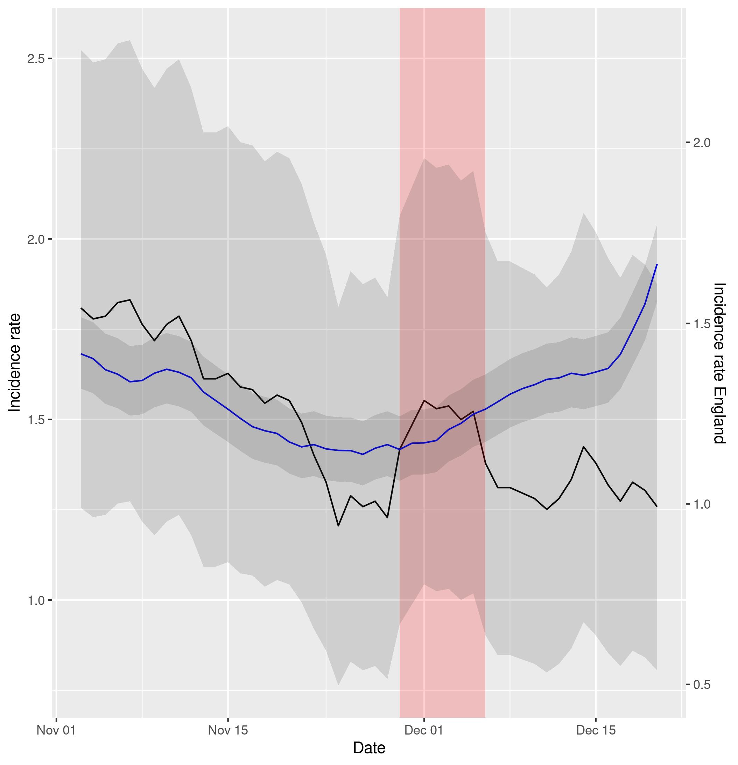
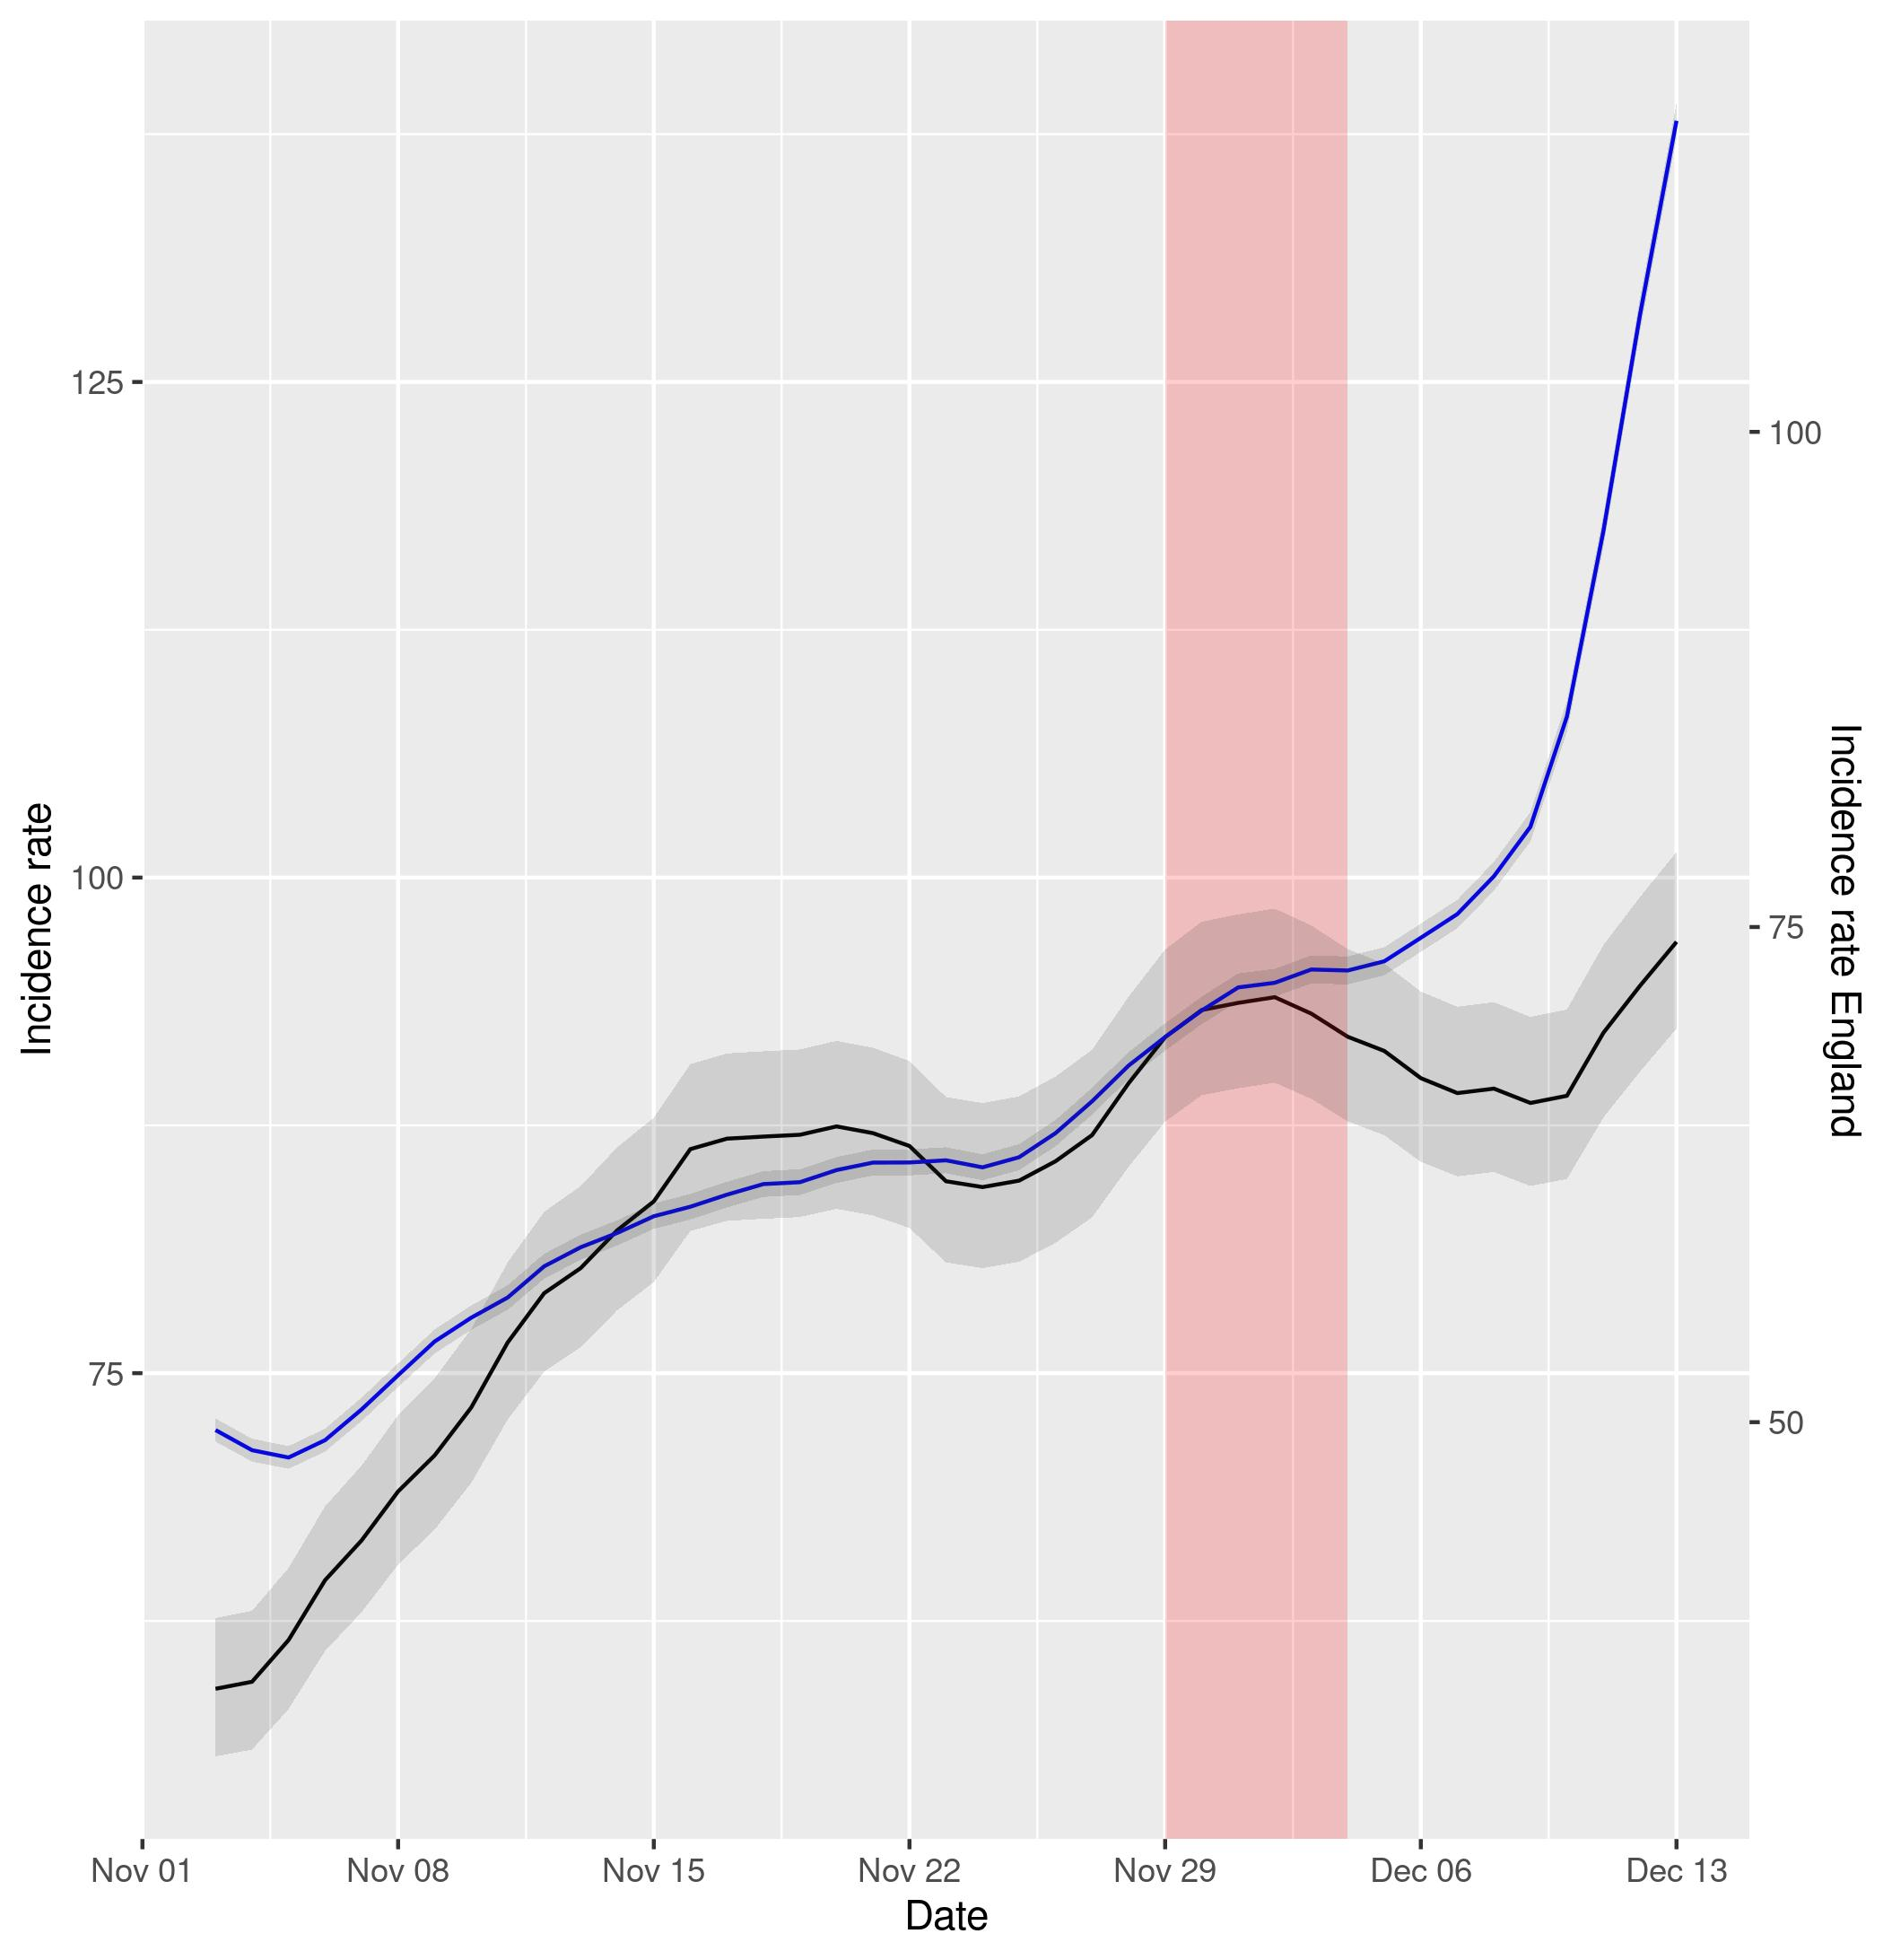

Figure 5a (left) and 5b (right). Representation of incidence rates of cases and hospital admissions in Northern Ireland (data in black) vs England (data in blue). Data has been displaced so that both curves intersect right at the intervention time point. The red shadowed area represents the neglected period post-intervention in the model due to the lag between the intervention and its effect and the grey shadowed area represents the 95% confidence intervals of the calculation of incidence rates.

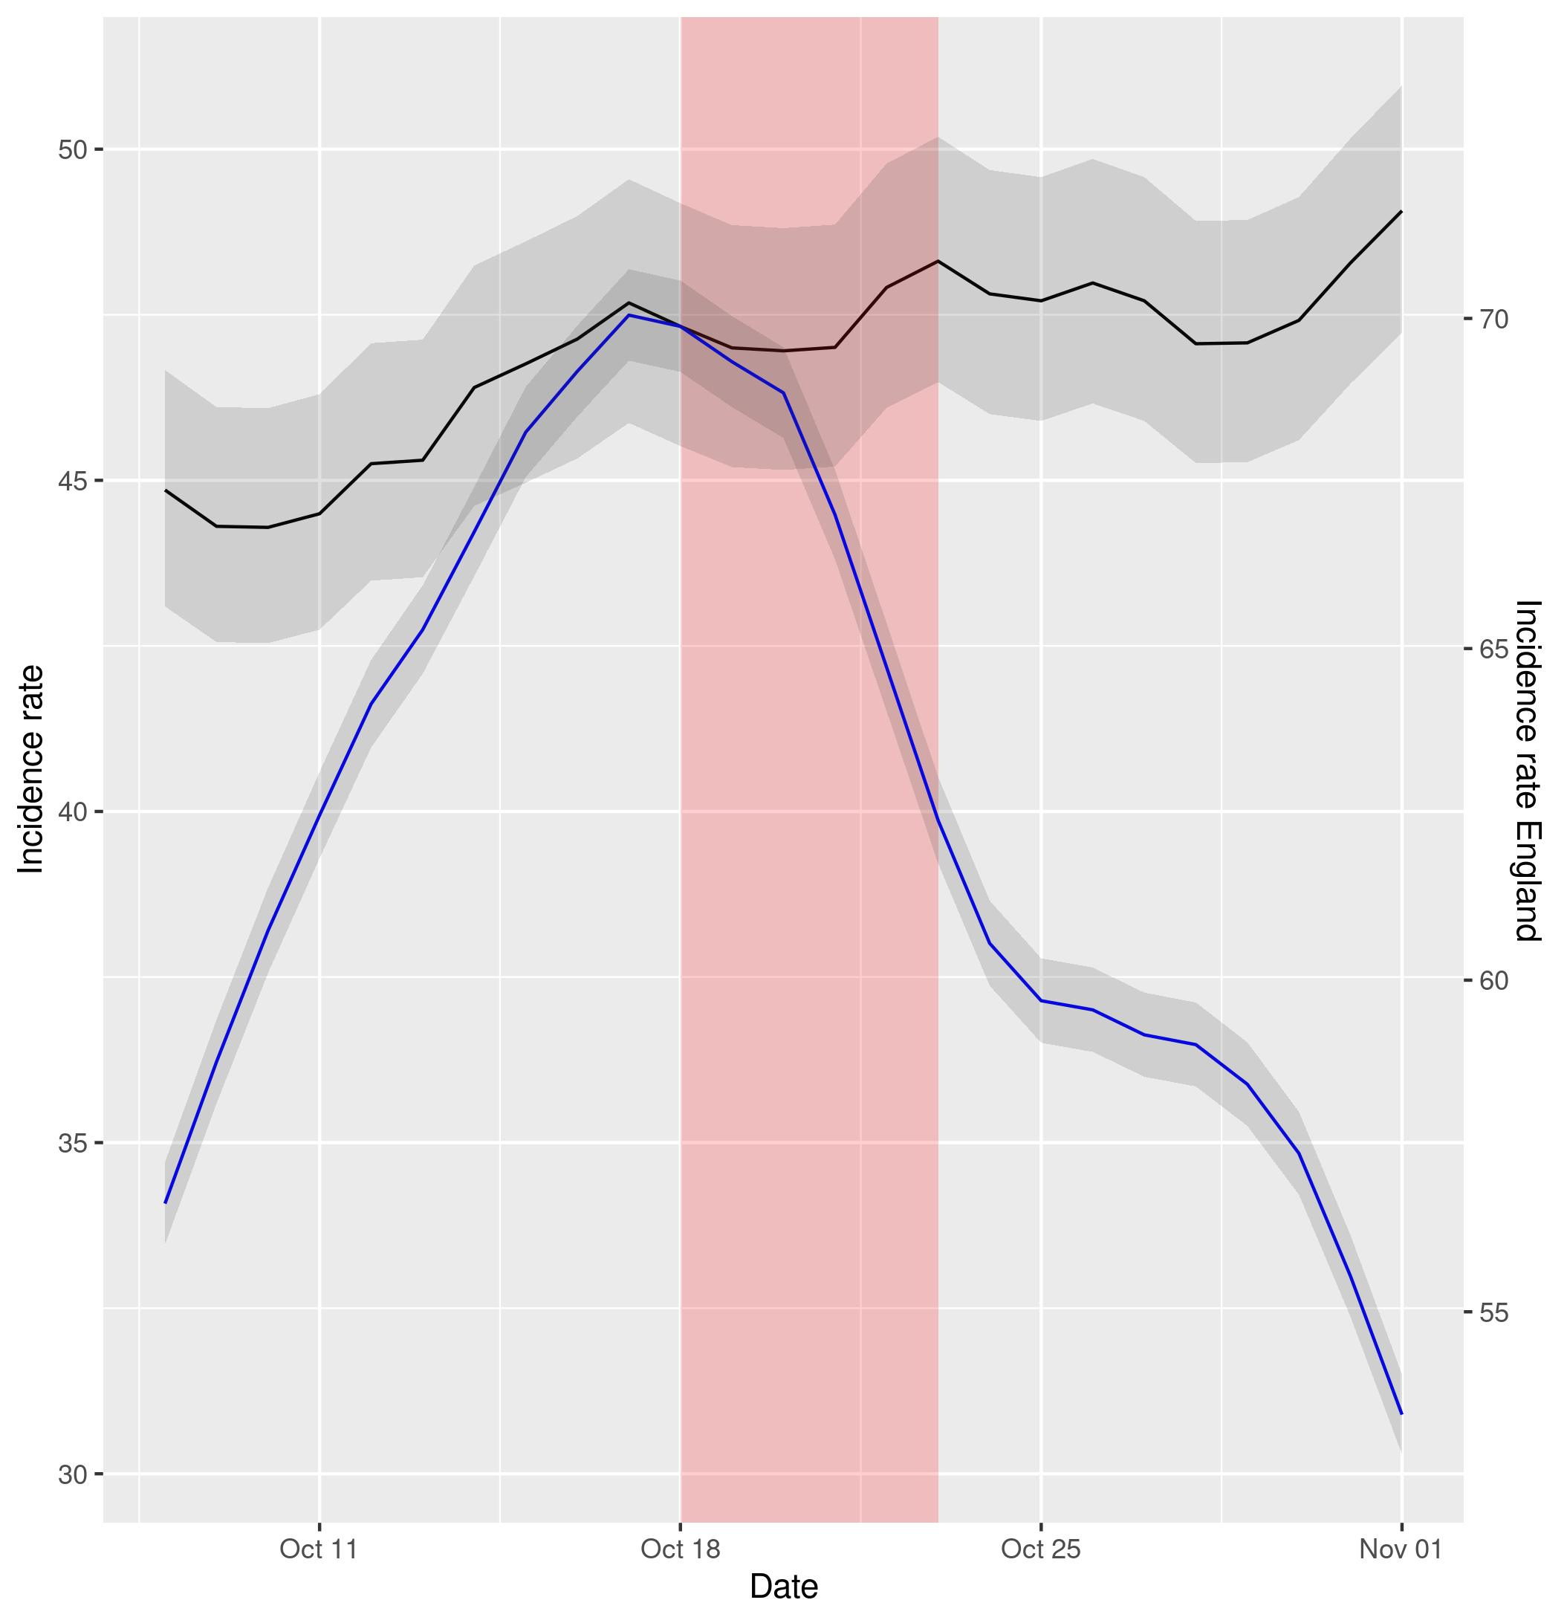
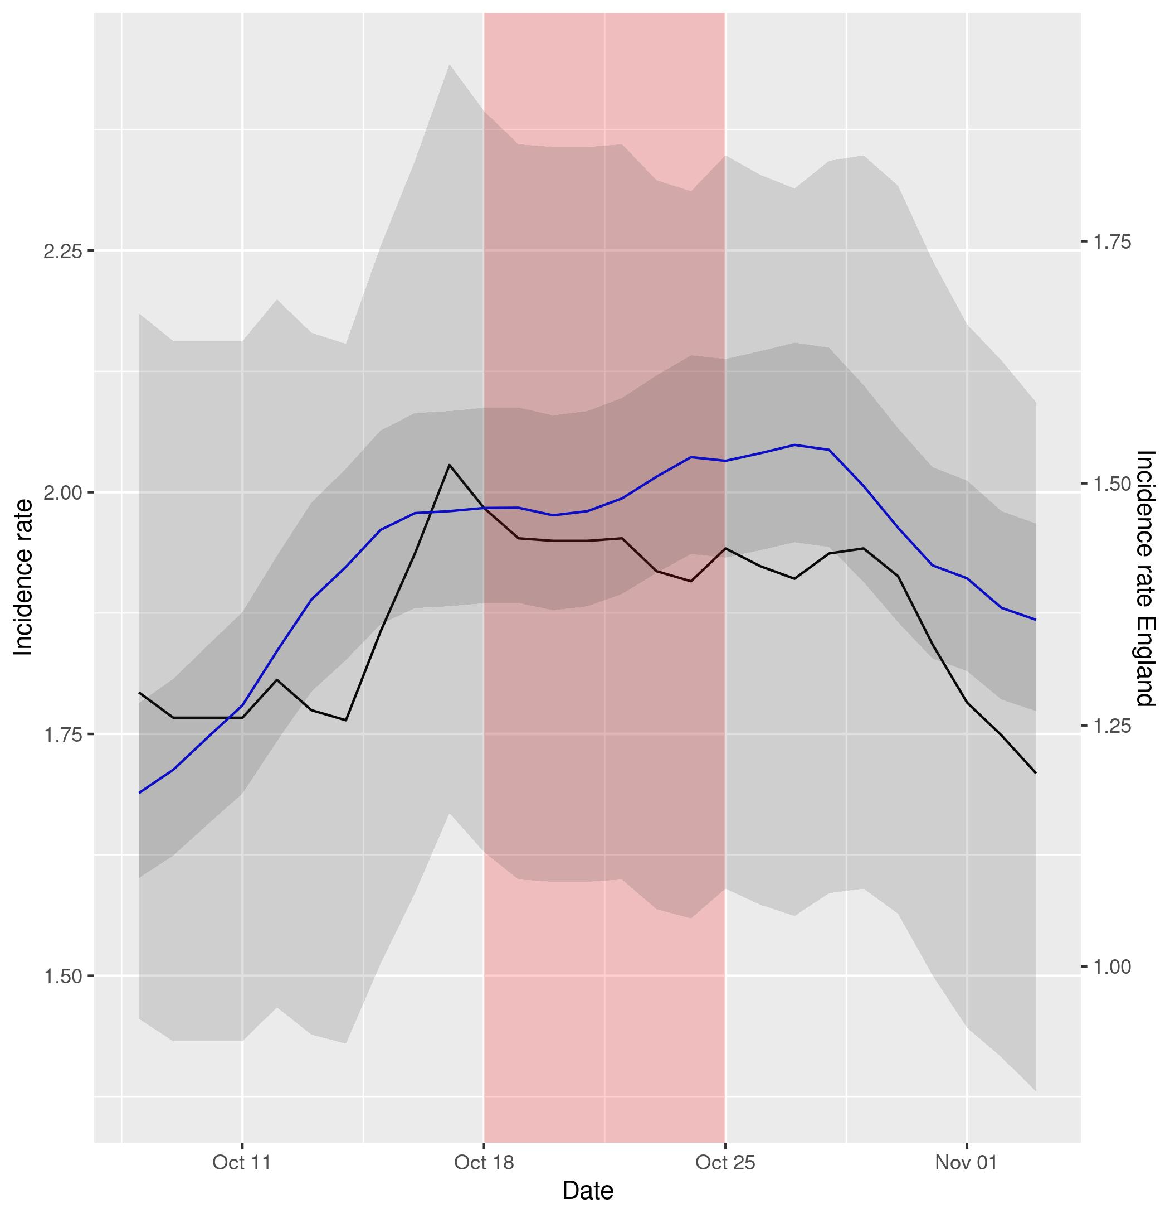

Figure 6a (left) and 6b (right). Representation of incidence rates of cases and hospital admissions in Scotland (data in black) vs England (data in blue). Data has been displaced so that both curves intersect right at the intervention time point. The red shadowed area represents the neglected period post-intervention in the model due to the lag between the intervention and its effect and the grey shadowed area represents the 95% confidence intervals of the calculation of incidence rates.

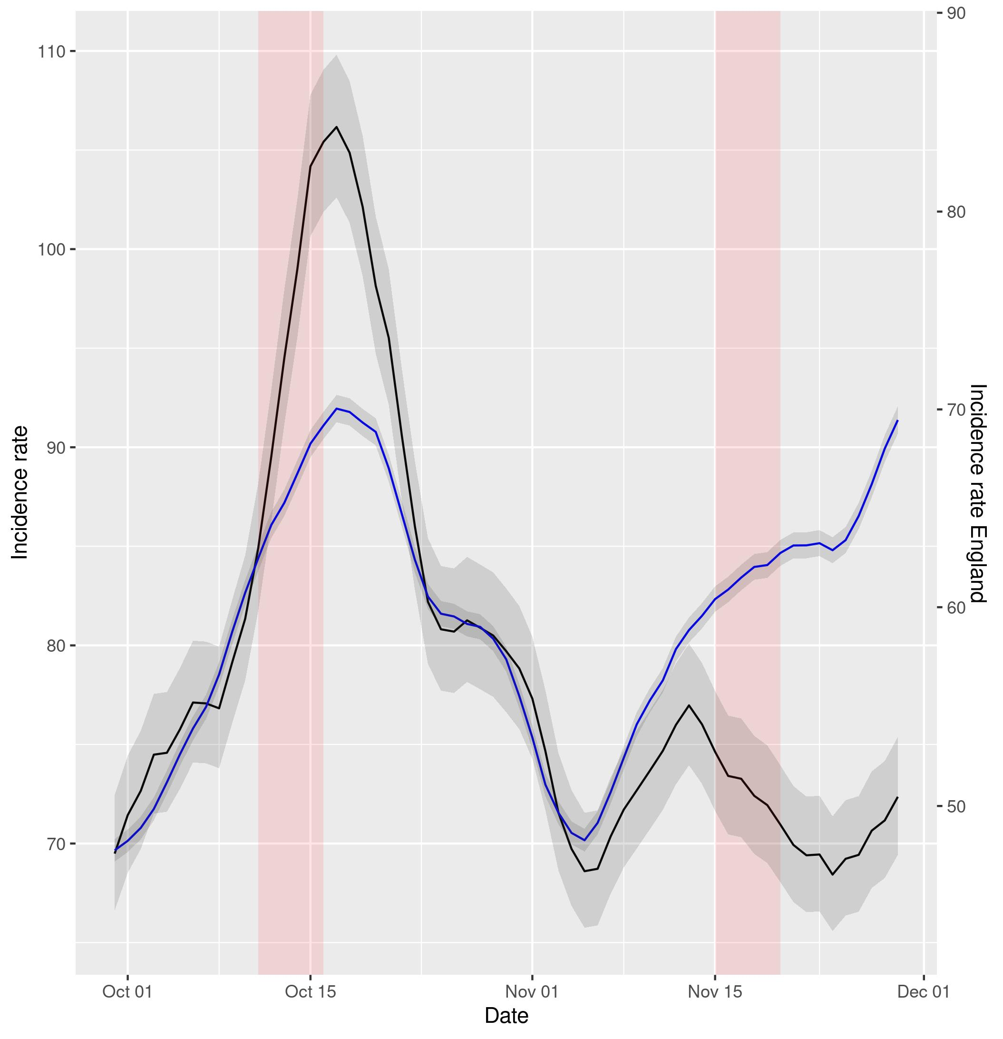
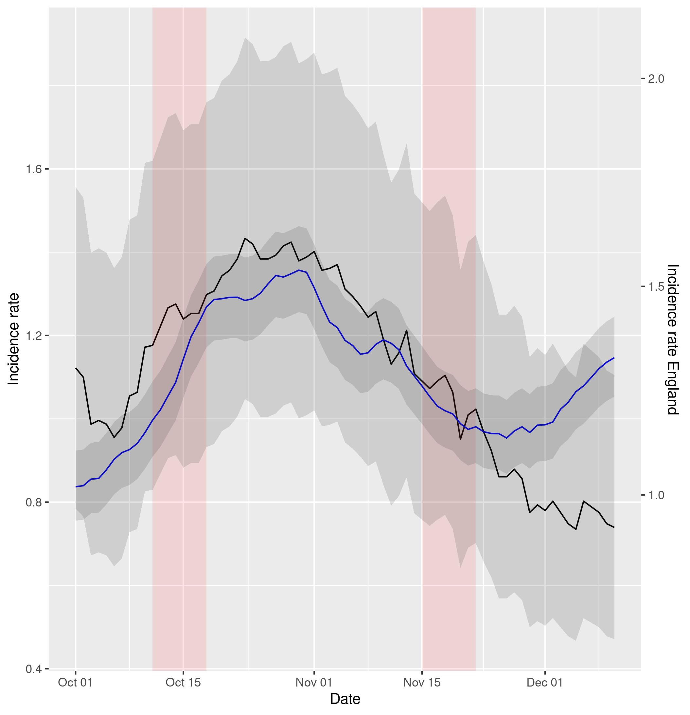
Figure 7a (left) and 7b (right). Representation of incidence rates of cases and hospital admissions in Wales (data in black) vs England (data in blue). Data has been displaced so that both curves intersect right at the intervention time point. The red shadowed area represents the neglected period post-intervention in the model due to the lag between the intervention and its effect and the grey shadowed area represents the 95% confidence intervals of the calculation of incidence rates.

DISCUSSION

Using NBSR modeling, we found Covid Passport interventions decreased incidence of COVID-19 cases in all countries except England, and decreased incidence of COVID-19 hospitalisation in Scotland. Wales plots, for instance, suggest a striking effect comparing to England, and in territories without geographic nor political barrier. ARIMA models, which control for autocorrelation of the observations, supported these findings. The visual difference in the NBSR plots, with England as a negative control group, reinforce the previous conclusions as well.

However, the study of Covid Passport intervention in England itself on the 15th of December 2021 shows that it was insufficient to prevent the increase in both incidence of cases and hospital admissions in the country. This might be due to the new Omicron variant of the virus, the effect of other coexistent measures or the already high uptake in vaccination.

To reinforce the visual way of assessing the difference in effect of Covid Passport between the different regions, a more quantitative way using DID methods was also provided. In this sense we could also test whether, even though the Covid Passport might not have had a direct effect of decreasing incidence rates in some countries, it could have led to a better control of the pandemic, using England as a counterfactual. We found significant effect of Covid Passport interventions for both incidence rates of cases and hospital admissions in Northern Ireland and the second half of November in Wales, compared to England, where the restriction was not into effect. The impact was not significant for the incidence rate of cases in Scotland nor October in Wales, yet it was for hospital admissions. Indeed, during that period the number of cases did decrease abruptly in Wales after the introduction of the Covid Passport. However, as they also decreased in England, the intervention effect was not so obvious. As for Scotland, the difference in trends pre-intervention for both groups is too acute to be able to interpret this model in a sensible way, as the assumptions for its validity are surely violated. In that sense, the DID plots provided for all regions and outcomes, compared to England, in which both trends have been superposed to better see its similarities and differences, serve as a check for the validity of this assumption. We note that this condition is arguably satisfied for all pairs except for cases in Scotland, and hence we can conclude that the reported positive effects are reliable.

These results are coherent with previous reported increased vaccine uptake after Covid Passport implementation (6), (7). Indeed, apart from the obvious restriction of mobility, the introduction of the Covid Passport and a subsequent increase in vaccine uptake could account for a lowering in both incidence of COVID-19 cases and hospitalisations. Moreover, this would explain the inefficiency observed in controlling the Omicron variant, as recent studies have reported lower effectiveness of the vaccines against it (12), (13).

Limitations of our analyses include the different covariates which might have affected the studied numbers and have not been accounted for. Time varying influential factors have possibly been controlled with DID methods taking England as a negative control group, yet other differences between the regions might be prevalent and affect the spreading of the virus differently. Moreover, the interventions were introduced at different times and with different limitations, and the response of the population to them might have been different in different regions. An unquestionably fair comparison is thus impossible.

The introduction of mandatory certificates was effective in decreasing cases in all countries except in England. This could be explained by differences of concomitant measures, on baseline vaccination uptake or by the emergence of the Omicron variant. Mandatory certification is only one of many policy levers to control the pandemic, and a sensible reassessment of its efficacy should be made by the competent authorities.

REFERENCES

(1) UK Health Security Agency, SARS-CoV-2 variants of concern and variants under investigation in England - Technical briefing 34 (2022). https://www.gov.uk/government/publications/investigation-of-sars-cov-2-variants-technical-briefings

(2) Flaxman, S., Mishra, S., Gandy, A. et al. Estimating the effects of non-pharmaceutical interventions on COVID-19 in Europe. Nature 584, 257–261 (2020). https://doi.org/10.1038/s41586-020-2405-7

(3) Askitas, N., Tatsiramos, K. & Verheyden, B. Estimating worldwide effects of non-pharmaceutical interventions on COVID-19 incidence and population mobility patterns using a multiple-event study. Sci Rep 11, 1972 (2021). https://doi.org/10.1038/s41598-021-81442-x

(4) Yang, B., Huang, A.T., Garcia-Carreras, B. et al. Effect of specific non-pharmaceutical intervention policies on SARS-CoV-2 transmission in the counties of the United States. Nat Commun 12, 3560 (2021). https://doi.org/10.1038/s41467-021-23865-8

(5) Mills MC, Dye C. Twelve criteria for the development and use of COVID-19 vaccine passports. R Soc. (2021). https://royalsociety.org/-/media/policy/projects/set-c/set-c-vaccine-passports.pdf?la=en-GB&hash=A3319C914245F73795AB163AD15E9021

(6) Mills, MD, Rüttenauer, Tobias. The effect of mandatory COVID-19 certificates on vaccine uptake: synthetic-control modelling of six countries. The Lancet Public Health 7 1 E15-E22 (2022).
https://doi.org/10.1016/S2468-2667(21)00273-5

(7) Walkowiak, M.P.; Walkowiak, J.B.; Walkowiak, D. COVID-19 Passport as a Factor Determining the Success of National Vaccination Campaigns: Does It Work? The Case of Lithuania vs. Poland. Vaccines 2021, 9, 1498. https://doi.org/10.3390/vaccines9121498

(8) COVID pass required at cinemas, theatres and concerts in Wales from next week, SkyNews (2021). Available at: https://news.sky.com/story/covid-pass-required-at-cinemas-theatres-and-concerts-in-wales-from-next-week-12464922

(9) Covid passports: How to get one, how to use one and can it be faked?, BBC (2021). Available at: https://www.bbc.co.uk/news/uk-northern-ireland-59331597

(10) How to get an NHS Covid Pass: Plan B Covid passport rules explained and where you need one for entry, iNews (2021). Available at: https://inews.co.uk/news/nhs-covid-pass-how-get-plan-b-vaccine-passport-new-rules-which-venues-need-explained-1352874

(11) What does the Scottish COVID-19 passport scheme mean for employers?, Brodies (2021). Available at: https://brodies.com/insights/employment-and-immigration/what-does-the-scottish-covid-19-passport-scheme-mean-for-employers/

(12) Kuhlmann, Constanze and Mayer, Carla Konstanze and Claassen, Mathilda and Maponga, Tongai G. and Sutherland, Andrew D. and Suliman, Tasnim and Shaw, Megan and Preiser, Wolfgang, Breakthrough Infections with SARS-CoV-2 Omicron Variant Despite Booster Dose of mRNA Vaccine (December 9, 2021). Available at SSRN: https://ssrn.com/abstract=3981711 or http://dx.doi.org/10.2139/ssrn.3981711

(13) Ferguson et al. Report 49 - Growth, population distribution and immune escape of Omicron in England, Imperial College London (2021)

